**The Ark Documentation.**

**Reports module.**

Log in and select your study by clicking the hyperlink corresponding to the name of your study.

Once you have chosen your study we will be able to adjust study details or select modules and functions available in that study (for which you have privileges).

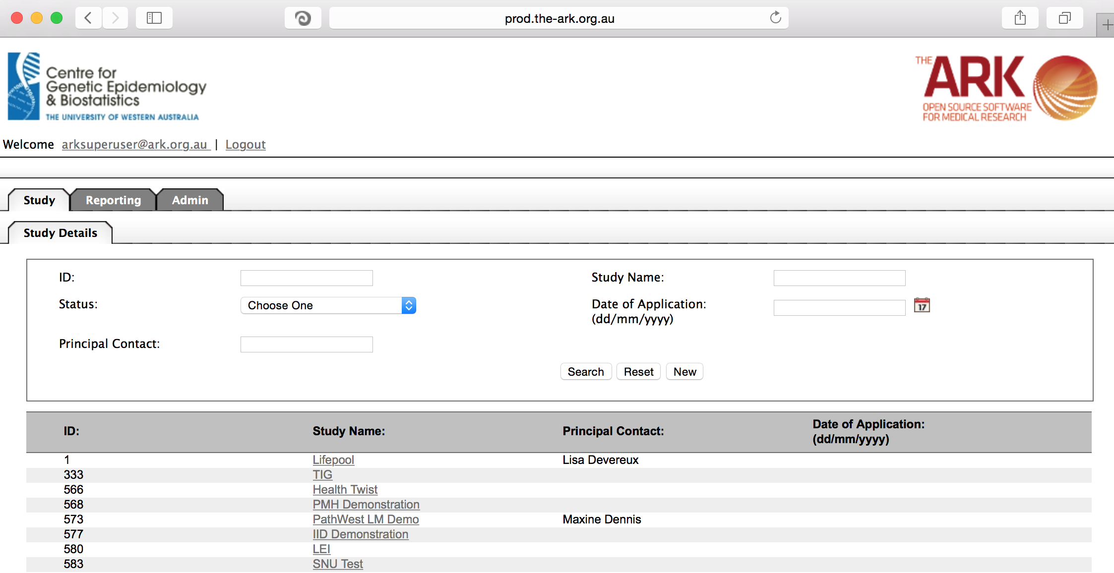

Alternatively if you have a very long list of studies under your management you may use the search pallette/panel at the top of the page. You can search/filter by id, name, principal contact, status of the study or date of application. Once you have added your filtering criteria, click the search button;

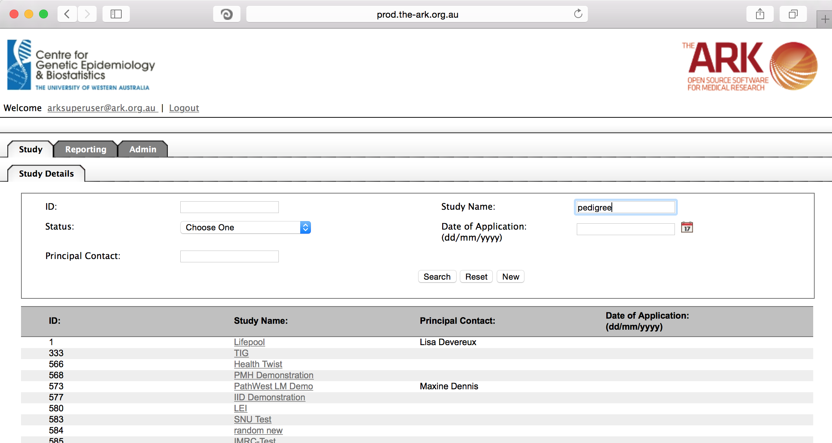

As you can see the filter has helped us find our chosen study and we can click the hyperlinked study name as discussed before;

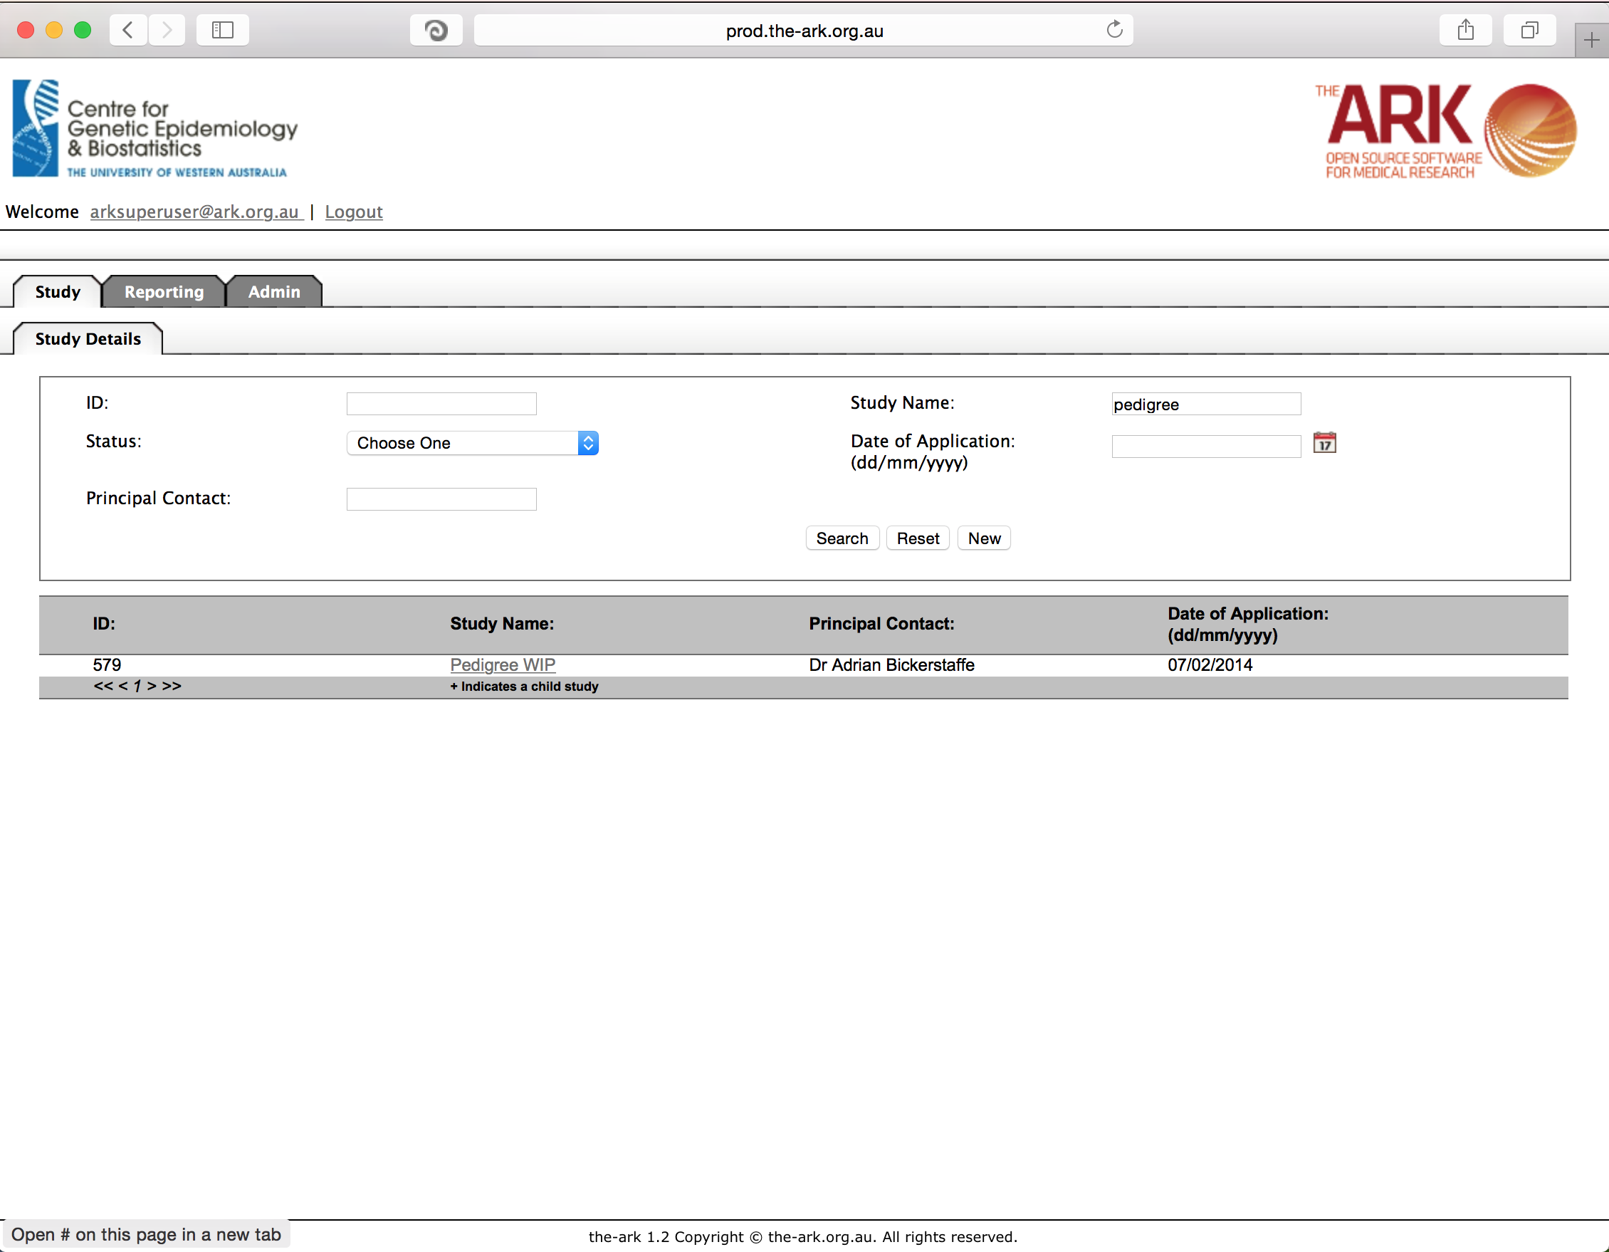

Once you have chosen your study we will be able to adjust study details or select modules and functions available in that study (for which you have privileges). The module we wish to select is Reports, the Reports function is then the default selection.

Most of our users just run standard prepared reports, which meets their needs. On occasions these pre-canned reports do no match the user’s needs, they can use the Data Extraction module to make a fully customized report without needing to know SQL.

For now we will concentrate on each of the standard reports.

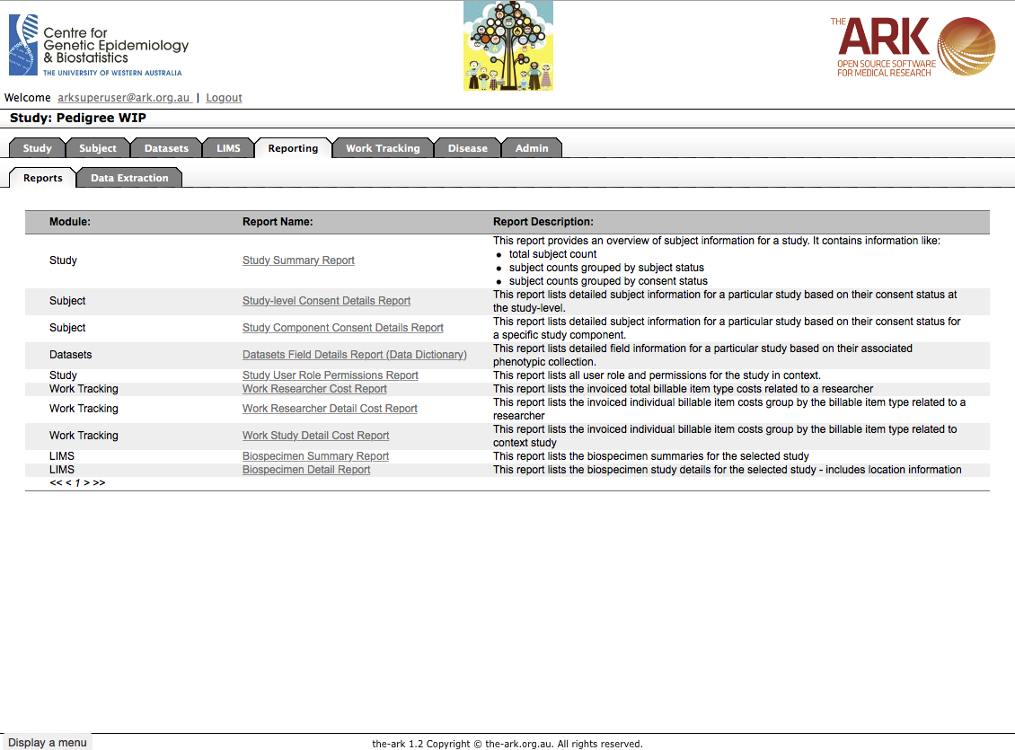

To run a report, simply click the hyperlink to the report you wish to run.

From there you will be presented with fields to filter if necessary.

Select/enter any filters, and the report output type (either CSV or PDF currently). Then Click generate. Depending on the size of the report this could be instantaneous or seconds/minutes in a worst case scenario.

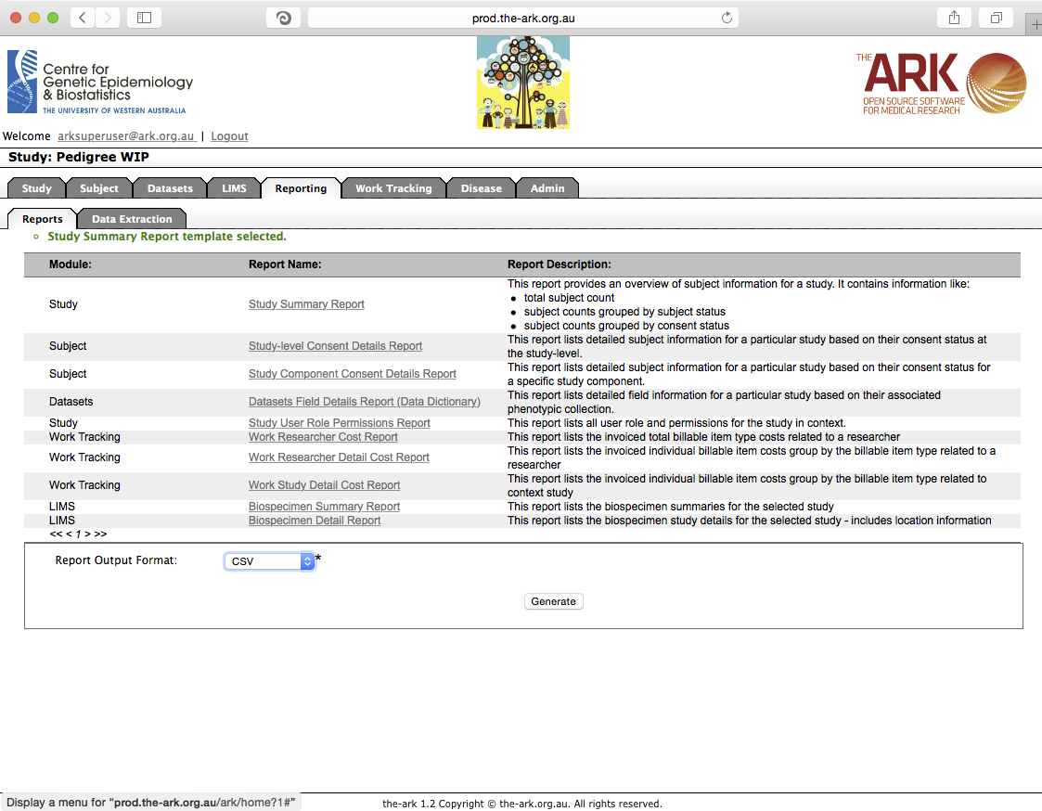

Now that you have generated the report you will be able to download it.

As you can see there is a Download report link once the generation has been completed. Click that link and your file will be downloaded in the standard manner/location your chosen browser usually downloads things to. (eg; Downloads folder in Safari).

